***TEAM DAREDEVILS***

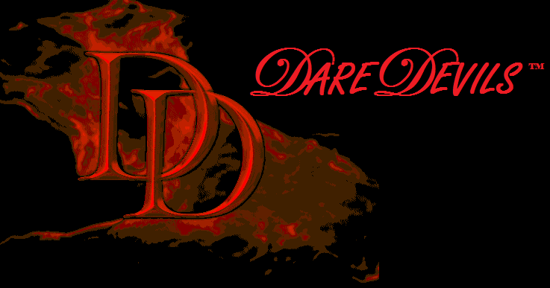

***MATLAB BASED GUI***

First week- 20th may to 26th may

In first week, we got familiarized with basics of MATLAB. We learned basic functions related to mathematics like factorial, multiplication. We learned basics of MATLAB thoroughly.

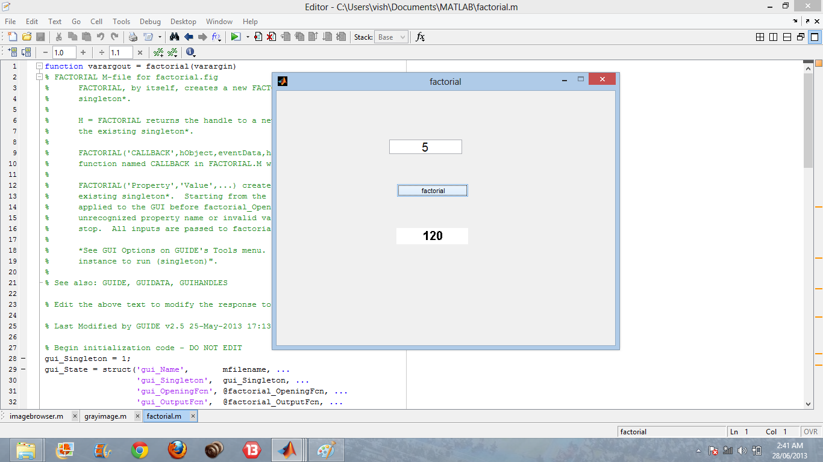

**2nd week-** 27th may to 2nd june

In the second week, we started working on GUI. We started developing some functions like gray image and also some other basic tools. It’s the week, we actually started our project.

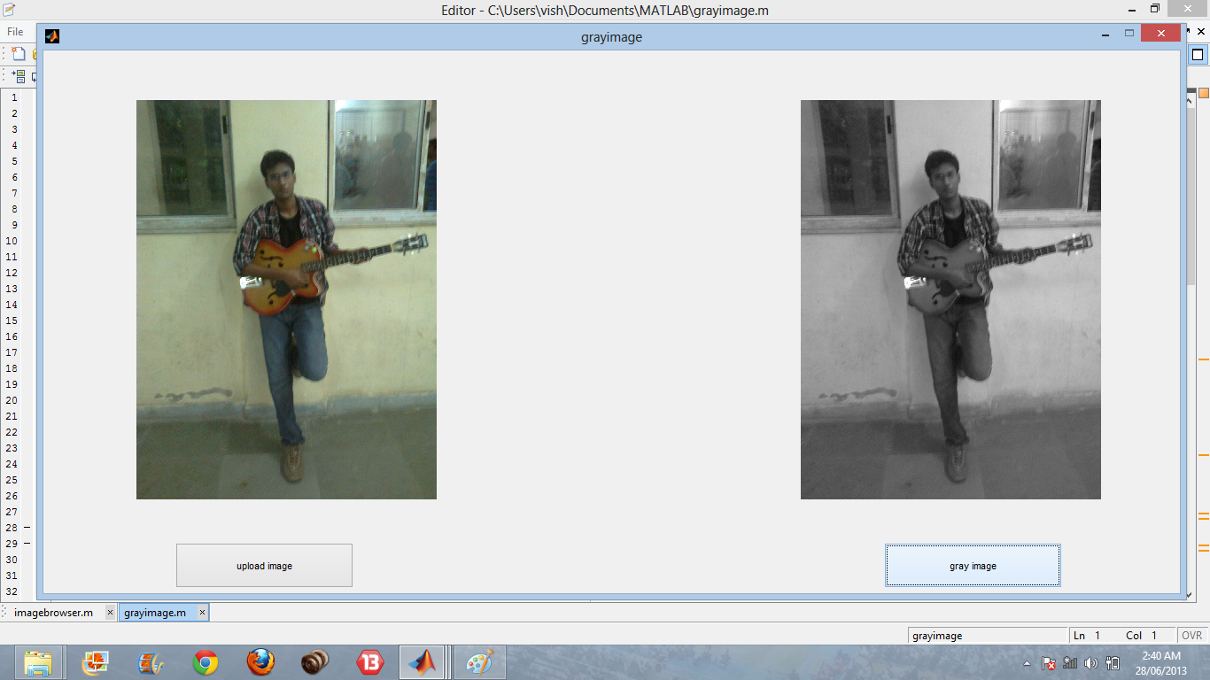

**3rd week-** 3rd june to 9th june

By this week, we nearly developed all tools necessary for our photoshop.

Then we clubbed these tools with help of pop menu,etc.

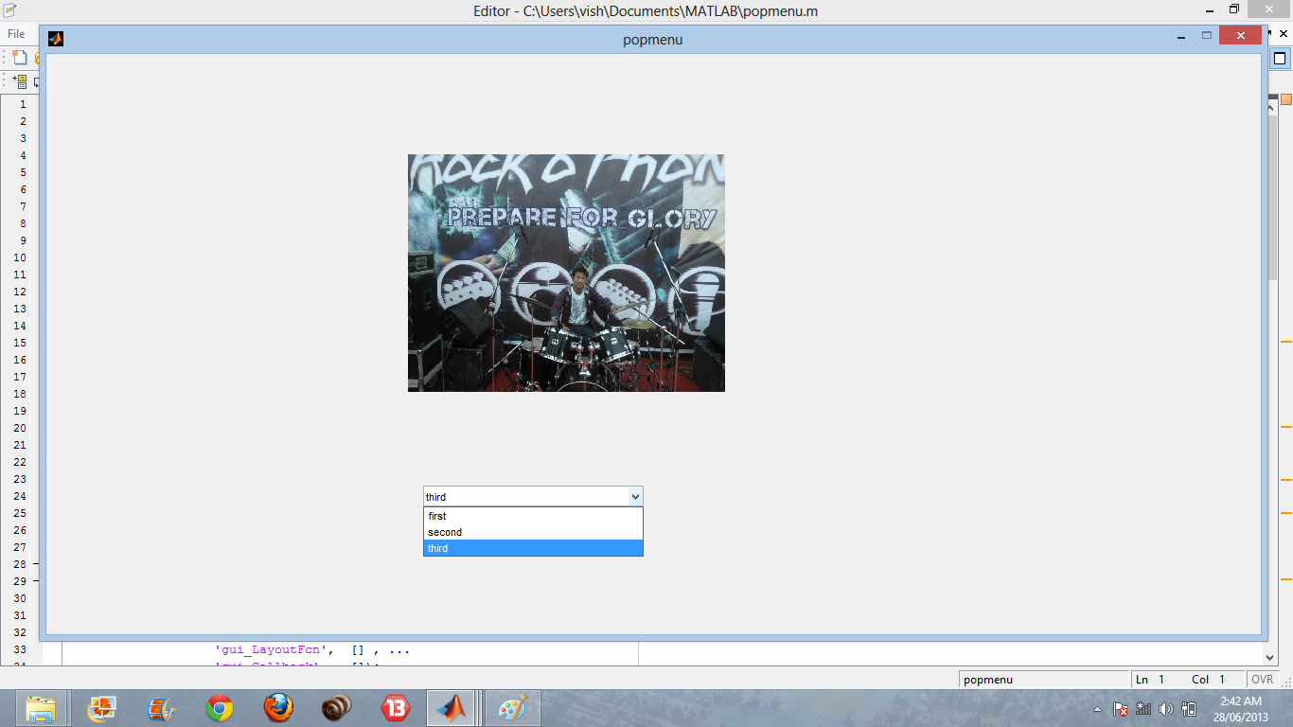

Also we worked on menu editor of our photoshop.

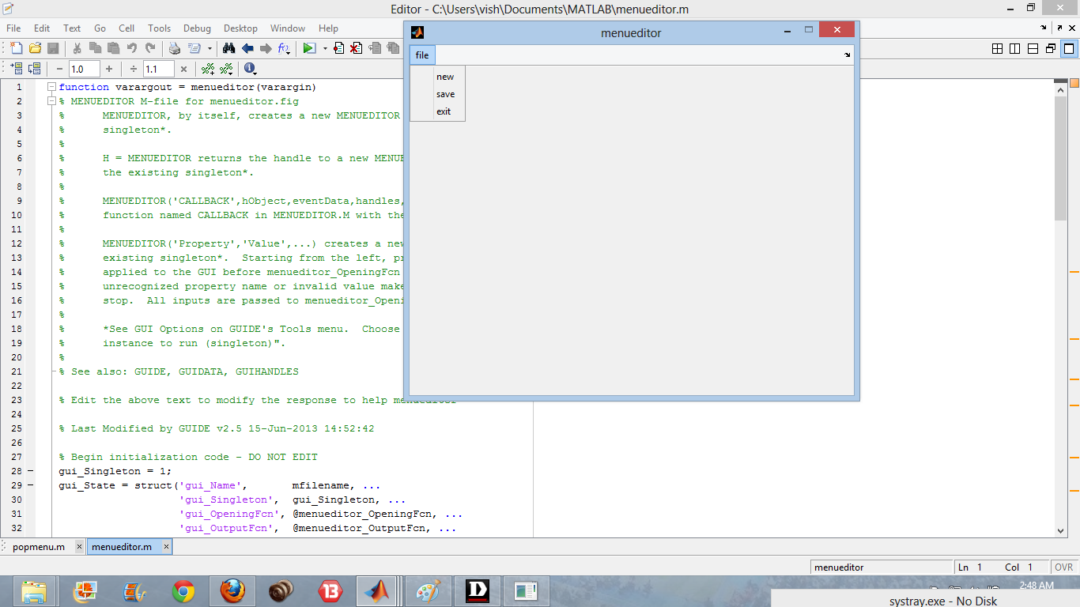

**4th week-** 10th june to 16th june

We clubbed all the tools and developed our final project in this week.

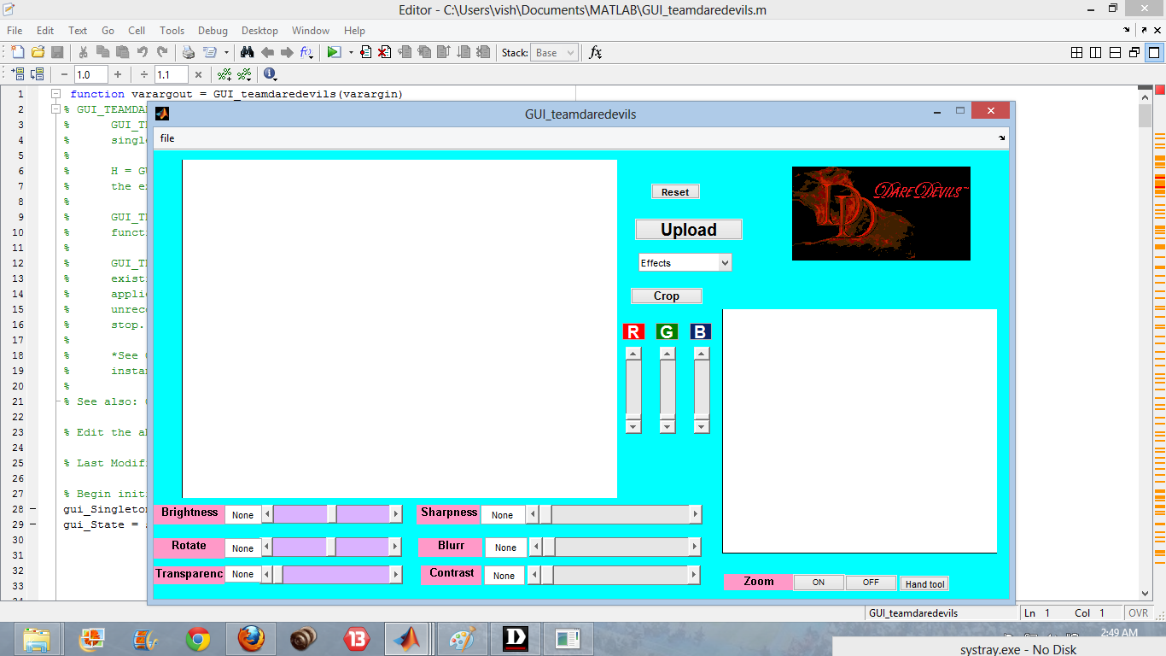

**5th n 6th week-**

In these weeks, we tried to remove the errors present in our project.

We worked on look of photoshop and other things.

We prepared video documentary on our project.

And our photoshop which we had basically aimed is ready 8) 8)

